No.F.51-361/2020-21/PSB (P&D)
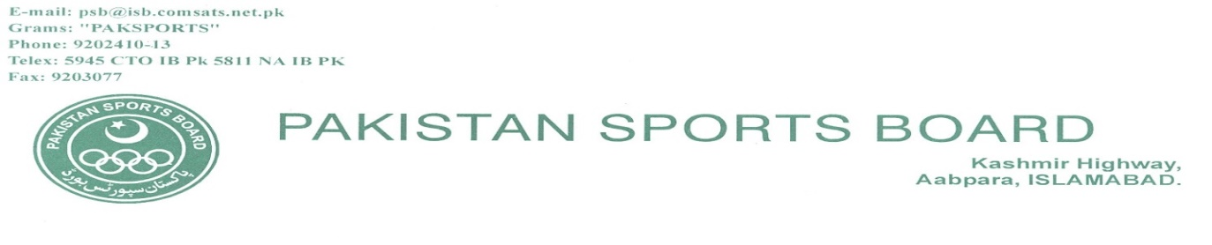

4th February, 2021

Subject: CORRIGENDUM

Kindly arrange the publication of attached advertisement in the leading daily newspapers having wise circulation according to the following specifications:-

i. Language: English & Urdu

ii. Region: Rawalpindi/Islamabad

iii. Date of insertion: 5th February, 2021

iv. Any special: 01 insertion in Urdu & 01 in English

2. Necessary per-receipted bill in duplicate duly supported by tear sheets etc. and verified by the Press Information Department (PID) may please be furnished to the undersigned for payment to proceed further.

Encl: As above
(M. Arslan Adil Ch.)
Executive Engineer (Civil)

The Deputy Director (Advt.),
Press Information Department,
Islamabad

Copy to:-

- DDG (Finance), PSB, Islamabad.
- Assistant Director (IT), PSB, Islamabad with the request to upload the attached corrigendum on website of PSB and PPRA with reference to PPRA Rule No.12.

PAKISTAN SPORTS BOARD
CORRIGENDUM
EXTENSION OF DATE

This corrigendum is being issued with reference to advertisement of our project titled “Rehabilitation & Upgradation of Existing Facilities at Pakistan Sports Complex, Islamabad”, published in different national newspapers and also uploaded on the websites of PRRA and Pakistan Sports Board. The date of submission of RFP documents has been extended to 15th February, 2021 till 1400 hours. The technical proposals will be opened on same day at 1430 hours. Other terms and conditions will remain unchanged.

(M. Arslan Adil Ch.)
Executive Engineer (Civil),
Pakistan Sports Board, Kashmir Highway, Aabpara, Islamabad.
Phone: 051-9249027 Fax:051-9249007

